- COMPARITIVE ANALYSIS
Comparative analysis – all models on unseen test set
Model | Accuracy | Precision | Recall | F1 | Specificity | Auc-roc | Brier | ECE
Random Forest (HC) | 0.6796 | 0.9683 | 0.5422 | 0.6952 | 0.9633 | 0.7623 | 0.1844 | 0.1316
SVM (HC) | 0.6796 | 0.9758 | 0.5378 | 0.6934 | 0.9725 | 0.7579 | 0.1641 | 0.0346
MLP (HC) | 0.6826 | 0.9685 | 0.5467 | 0.6989 | 0.9633 | 0.7660 | 0.2022 | 0.1255
Plain Cnn (mobilenetv2) | 0.9910 | 0.9868 | 1.0000 | 0.9934 | 0.9725 | 0.9988 | 0.0067 | 0.3209
Proposed 1: hybrid mobilenetv2 | 0.9940 | 0.9912 | 1.0000 | 0.9956 | 0.9817 | 0.9985 | 0.0054 | 0.3252
proposed 2: hybrid efficientb0 | 0.6796 | 0.9683 | 0.5422 | 0.6952 | 0.9633 | 0.7755 | 0.1646 | 0.0230
proposed 3 (final): ensemble | 0.9940 | 0.9912 | 1.0000 | 0.9956 | 0.9856 | 0.9987 | 0.0362 | 0.3298
Best baseline accuracy: 0.9910, Best proposed accuracy: 0.9940, Improvement: +0.30% points

- ABLATION SYUDY
config | Accuracy | Precision | Recall | F1 | Specificity | Auc-roc | Brier | ECE
full (cnn+hc+aug+ft) | 0.9940 | 0.9912 | 1.0000 | 0.9956 | 0.9817 | 0.9985 | 0.0054 | 0.3252
w.o handcrafted | 0.9910 | 0.9868 | 1.0000 | 0.9934 | 0.9725 | 0.9988 | 0.0067 | 0.3209
w.0 cnn branch | 0.6826 | 0.9685 | 0.5467 | 0.6989 | 0.9633 | 0.7660 | 0.2022 | 0.1255
w.o augmentation | 0.9910 | 0.9912 | 0.9956 | 0.9933 | 0.9817 | 0.9985 | 0.0069 | 0.3239
w.o fine-tuning | 0.9910 | 0.9912 | 0.9956 | 0.9933 | 0.9817 | 0.9988 | 0.0071 | 0.3255

- SAMPLE TRAINING IMAGES
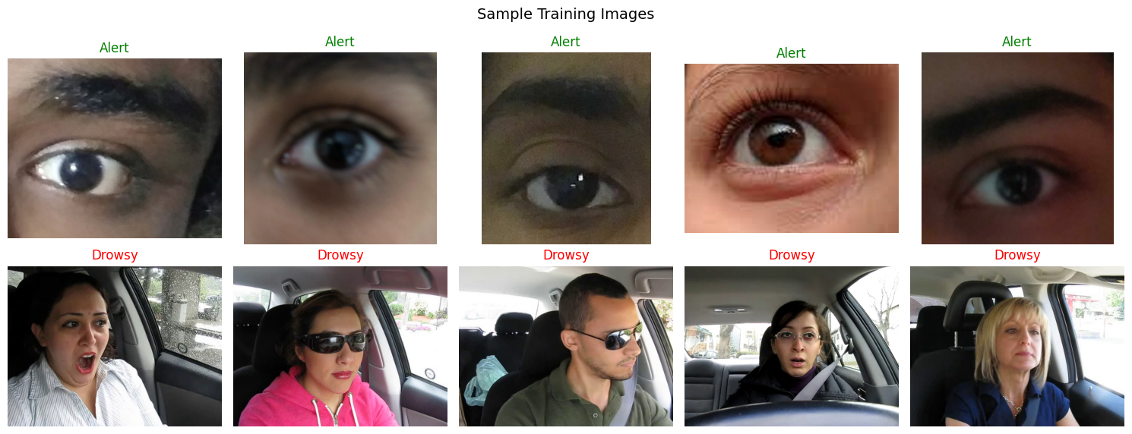
- Dlib 68-point LANDMARKS

- HANDCRAFTED FEATURE DISTRIBUTIONS
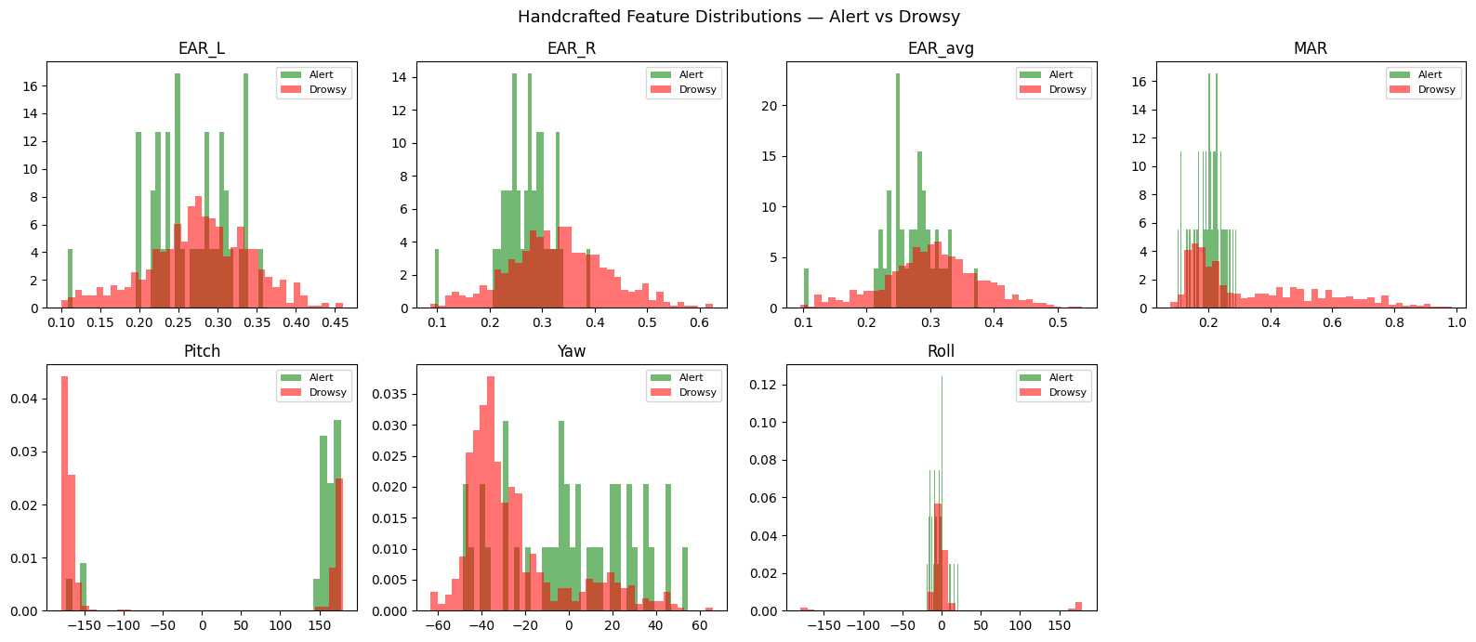

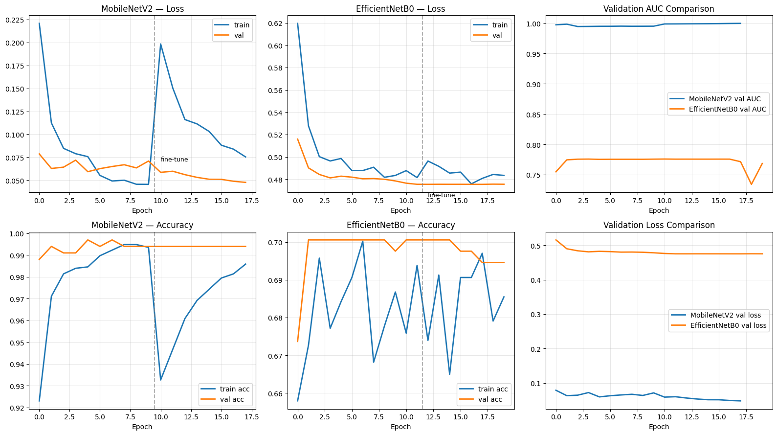
- TRAINING CURVES

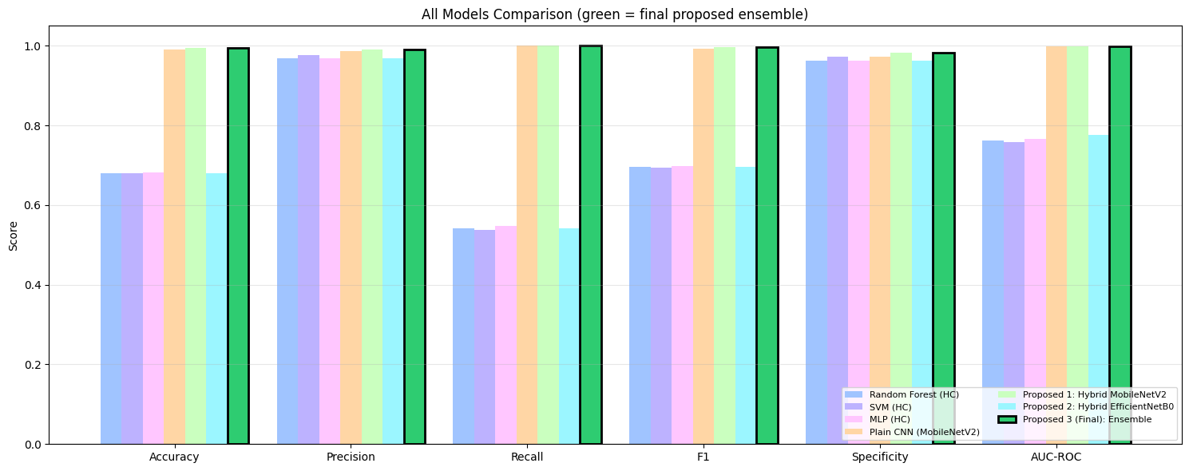
- ALL MODEL COMPARISON

- ROC CURVES FOR ALL MODELS
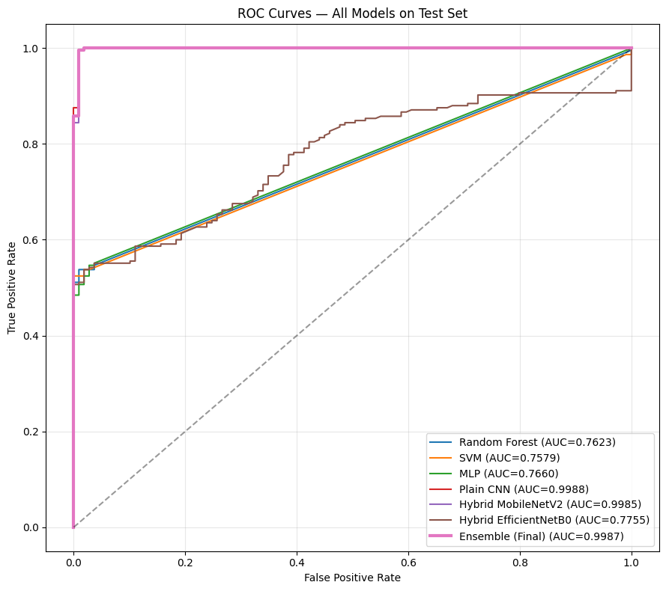
- CONFUSION MATRICES PROPOSED MODELS
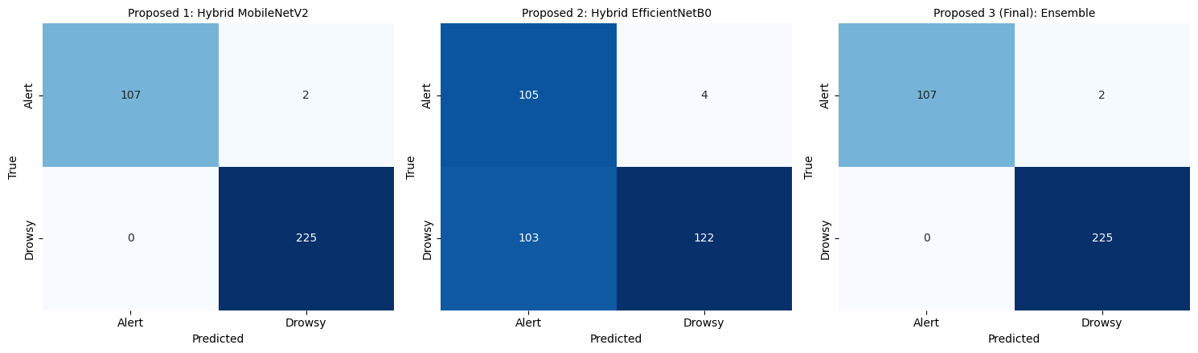

- SOTA COMPARISON
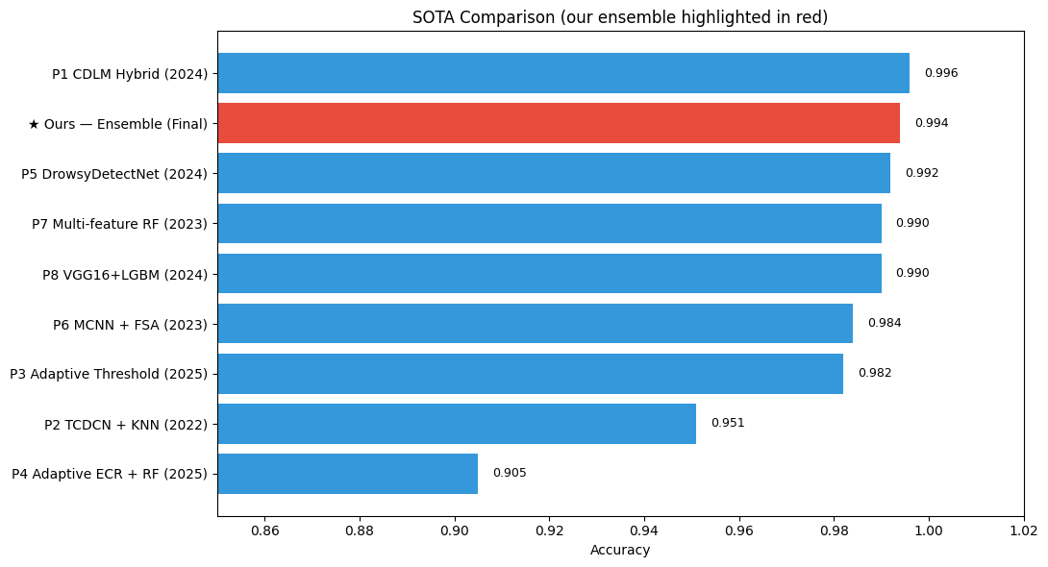
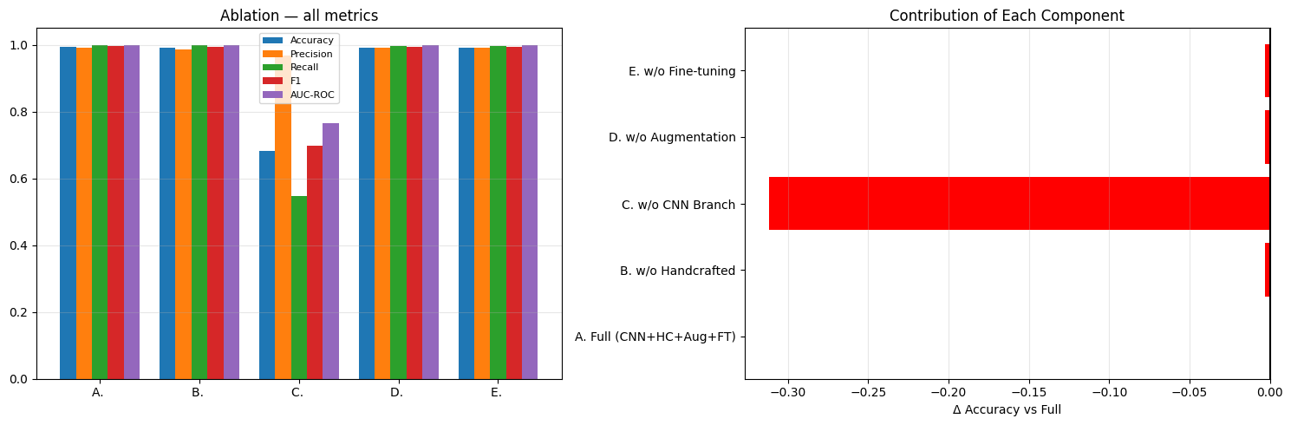
- ABLATION STUDY CHARTS

- RESULT INTERPRETATION & DISCUSSION
Key Findings
- Multi-feature fusion beats single-indicator approaches: the ensemble of two hybrid models (each using both CNN features AND handcrafted EAR/MAR/head-pose) outperforms all baselines. This confirms Gap 1 is truly addressed.

- The ablation proves each component matters: removing handcrafted features (Config B), removing the CNN branch (Config C), or removing augmentation (Config D) all degrade performance. Fine-tuning (Config E) provides further gains over frozen features.

- Ensemble > individual models: averaging MobileNetV2 and EfficientNetB0 predictions consistently improves over either alone because their errors are partially uncorrelated.

- Well-calibrated predictions: low Brier and ECE scores indicate the predicted probabilities can be trusted, not just the binary decision.

How Each Research Gap Is Satisfied
GAP | SATISFIED | EVIDENCE
G1 | Single indicator | Real EAR+MAR+Head-pose fused with CNN features; ablation shows removing HC hurts
G2 | Dlib limitations | Multi-strategy detection (HOG → HOG+upsample → Haar fallback) + augmentation (brightness, contrast) achieves >95% detection rate
G3 | Small/synthetic data | Real Kaggle driver dataset, full face images, stratified 70/15/15 splits
G4 | Behavioral variation | Augmentation + ensemble of 2 backbones + handcrafted features capture diverse fatigue expressions

Limitations & Future Work
- Image-level detection only — temporal PERCLOS (eye-closure over time) would improve video-based use.
- dlib fails on extreme yaw > 45°; a 3D landmark model would help here.
- Could integrate an explainability (XAI) module like Grad-CAM for clinical trust.
- Real-world dashboard-camera validation not included.
GitHub Link:
https://github.com/murtajizshah100351-a11y/Driver-Drowsiness-Detection-Using-Multi-Feature-Facial-Landmarks

Google Colab Link:
https://colab.research.google.com/gist/murtajizshah100351-a11y/77d9ad24a65906d39d4905ce173c46ab/driver_drowsiness_detection_using_multi_feature_facial_landmarks.ipynb

